24.38: a) 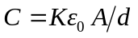gives us the area of the plates:
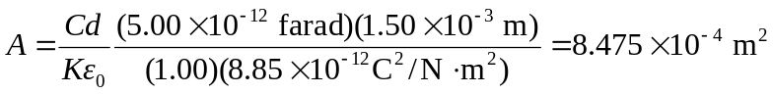
We also have field between the plates, which is not to exceed 
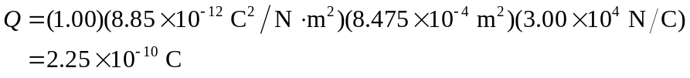
b) Again, 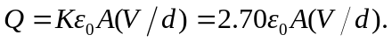 If we continue to think of 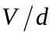as the electric field, only K has changed from part (a); thus Q in this case is

